|  |  |  |
| --- | --- | --- |
|  | PREPARING YOUR HOME FOR YOUR NEW KITTEN  RECOMMENDED ESSENTIALS;  WET FOOD AND DRY  Royal Canin brand  Kitten dry kibble,  I recommend leaving dry food out all the time in a deep bowl or dry food feeder.  Wet food,  Select the kitten, thin slices in gravy.  Feeding your kitten  I recommend feeding wet food 3 times daily, 2 heaping tablespoons per feeding  Mornings, early evening and before bedtime.  LITTER;   My preferred brand of litter is:  SWheat Scoop  Wheat based, the litter lasts a long time and does not scatter much or ammoniate!  EQUIPMENT;  Litter boxes  Best buy on the market…is aplastic cement trough!  You can find them at a Home Depot in the building department near the cement.  Definitely select a medium to large high walled litter box, no lids!   I recommend 2 boxes per cat if you have room in your house.  A sifter rake to clean the litter  Rake holder or caddy to hold your rake  Poop bags  For poop bags my preference is large poop doggy bags, the bags come on a roll in a box and  make it easy to tear off.  ELECTRIC WATER FOUNTAINS  DrinkWell brand, electric stainless steel or plastic.  Regarding water fountains, there are many on the market, make sure it is not too tall, the ones  with a daisy flower for the spouts, those are fun but they accumulate what I call “scouch” or become slimey!  Remember to order extra filters for the model youultimately choose.  CAT CONDOS, CLIMBING TREES, BEDDING  Amarakat brand premium models are solid construction and are all wood.  I prefer the wood construction instead of the carpeting which is quickly destroyed over time  and gets very dirty!  I can order a condo tree for you as I get a wholesale discounted price.  Go to Amarakat.com  Look at all their models, I prefer the premium wooden models.  I can have the cat condo drop shipped to your house,  or you can pick up it when you get your kitten at the cattery.   * Soft cozy bedding, some cotton content is advisable but make sure the bedding is washable! * Scratching posts or cardboard wedges are always a good idea!!! * Cat feeder for dry kibble Stainless steel feeding bowls for wet food * Toys, toys and more toys, never enough toys to spoil kittens |  |

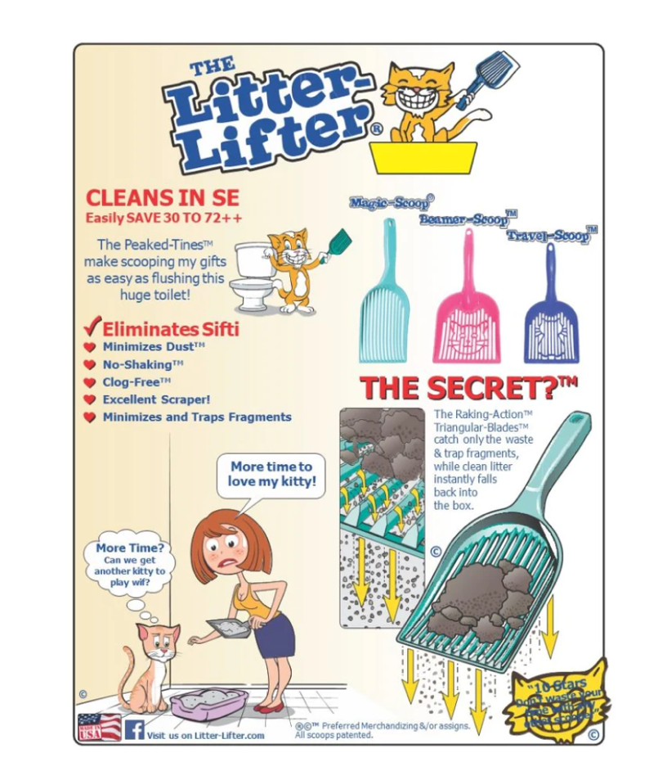

Recommended Scooper

Recommended hair remover

Recommended litter

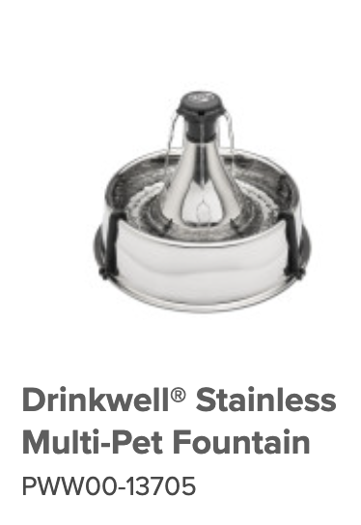

ELECTRIC WATER FOUNTAIN

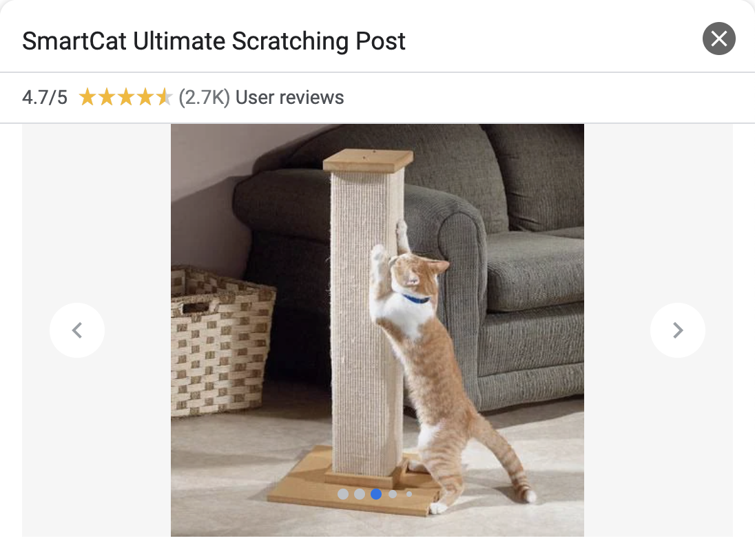

Scratching posts, highly recommended!!!!!!

Bringing home your kitten

Bringing home and the first few weeks of owning a kitten, although exciting, can be challenging. By having the right tools and knowledge, you can make sure that this first experience with your new arrival is a positive one, for them and for you.

## What you’ll need to know and provide for to care for your kitten before bring him or her home.

There’s a lot to consider when it comes to welcoming a new kitten. You’ll need to be fully prepared before bringing them home and know how to approach their first day and night with you, including what to feed them.

Link

https://www.royalcanin.com/us/cats/kitten/kitten-feeding-and-nutrition

Wet, minced meat in gravy and Dry, Royal Canin kitten kibble

Keep dry food out all the time and feed 2 to 3 times wet food 2 to 3 tablespoons er feeding.

If you feel our kitten required more it cannot hurt the kitten to add more into the bowl once they have finished the entail portion.  
  
During the first week, it’s best to begin establishing routines as well as taking them to the vet and beginning to socialize them. And it’s important to know how to introduce your kitten to friends, family, children, and other pets.

Are you ready to bring your kitten and introduce them into your home?

It’s important to be fully prepared before bringing your kitten home. Make sure you’ve kitten-proofed your home and set up a room with everything they'll need, including a bed, food and water bowls, a litter box, a collar with a bell and toys. Interactive toy are sometimes very pricy and intended to only amuse we humans, not kittens or cats!

You will need a cat carrier to carry your kitten home. A medium size, top loading, front loading carrier and include a puppy pad or provide a washable soft liner, blanket or cushion.

**Veterinarian**

It’s also a good idea to find a vet you trust and make an appointment for a check-up a few days after bringing them home or follow up with the vaccination series FVRCP, Upper respiratory, Distemper.

.